

Programme Name: ________**BCS HONS**_______________________________________

Course Code: __**STAT 1000**________

Course Name: ________**Introduction to Statistics**______________________________

**Open Book examination**

Date of Submission: ______**5/27/2021**_____________

**Submitted By: Submitted To:**

Student Name**: CSC_1000_Dipesh Tha Shrestha** Faculty Name**: Shanta Rayamajhi Basnet**

IUKL ID: **041902900028** Department**: LMS**

Semester**: Third Semester**

Intake**: September 2019**

**Section A**

**Question 1**

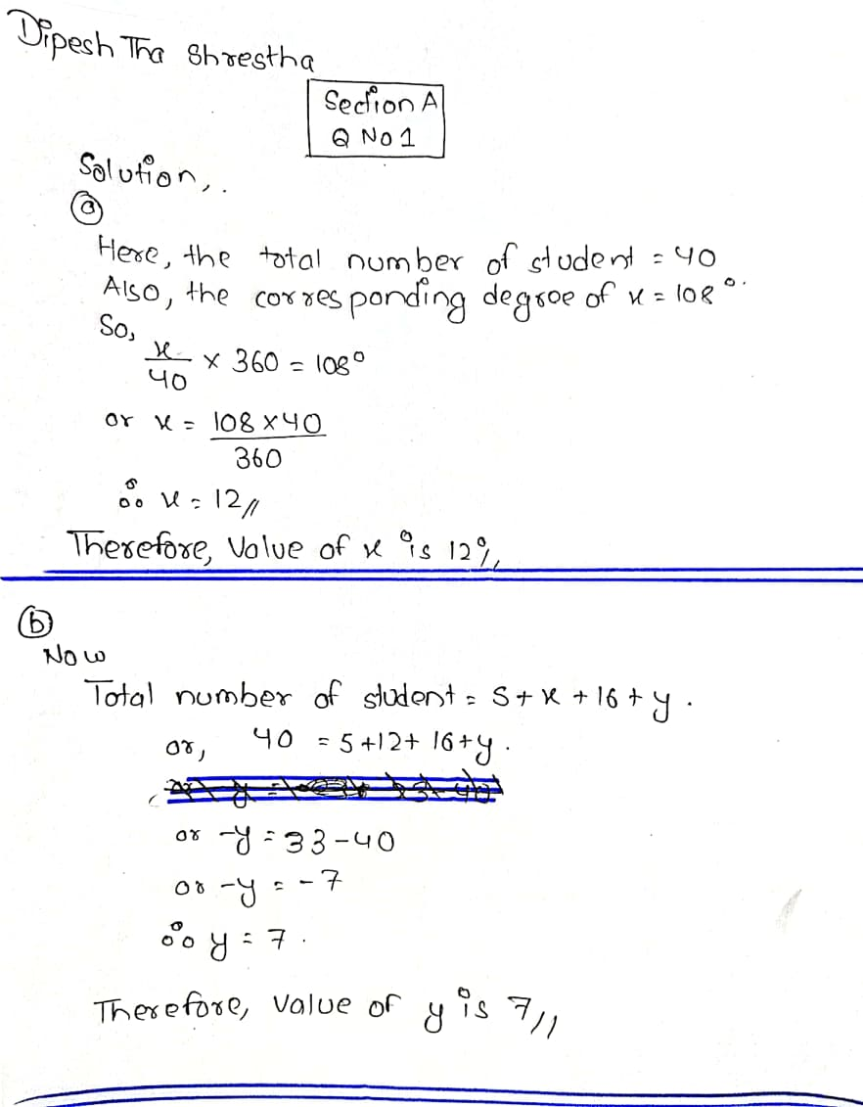

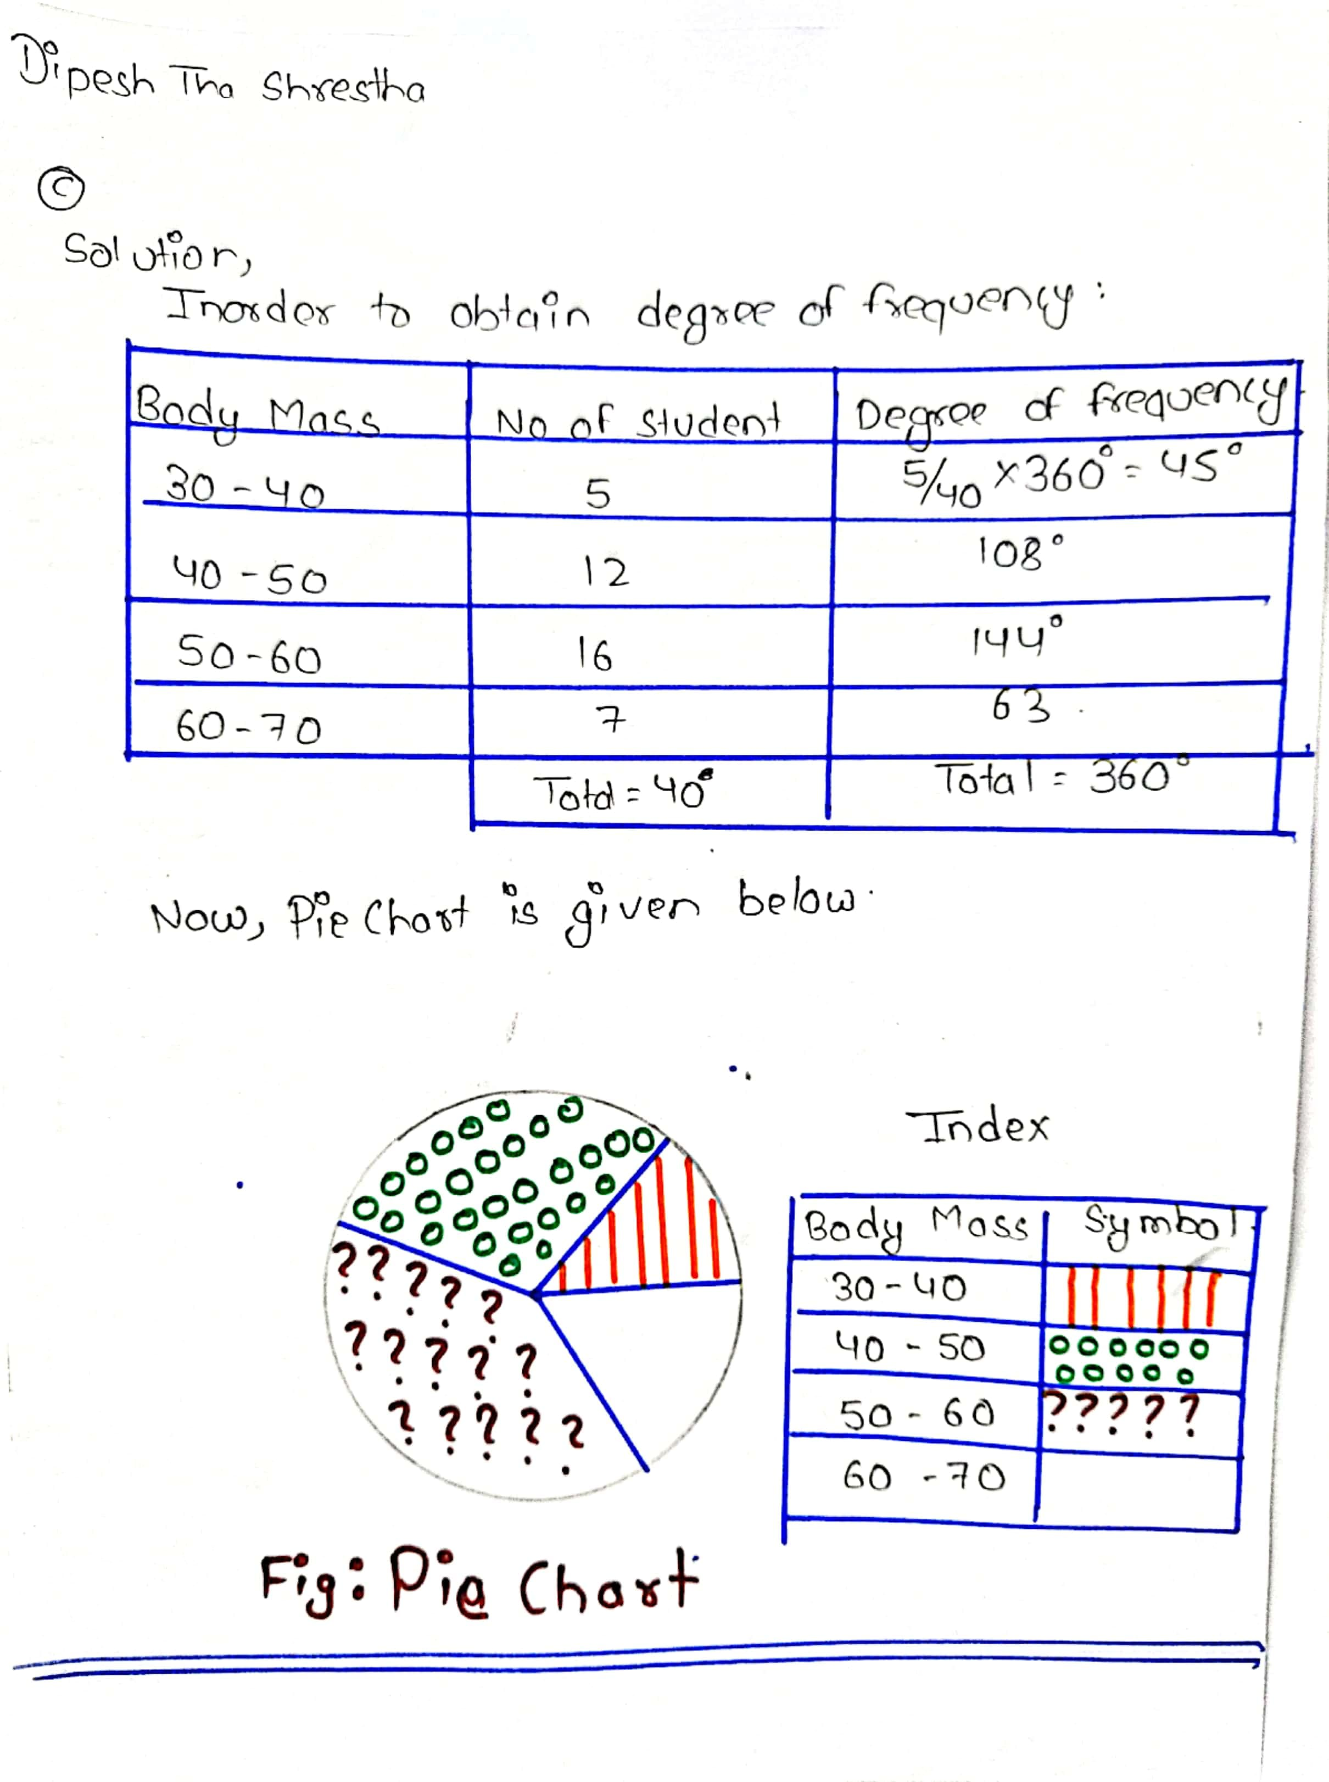

**Question 2**

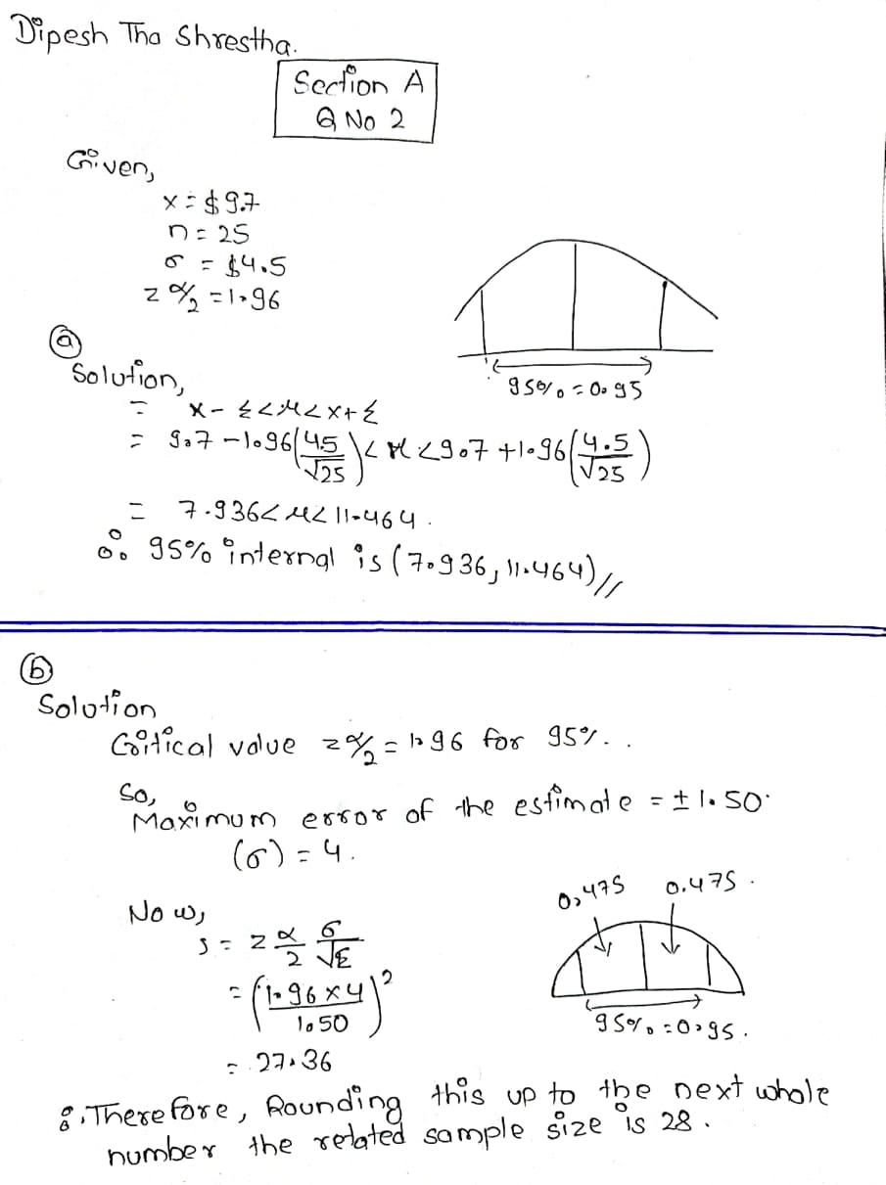

**Question 3**

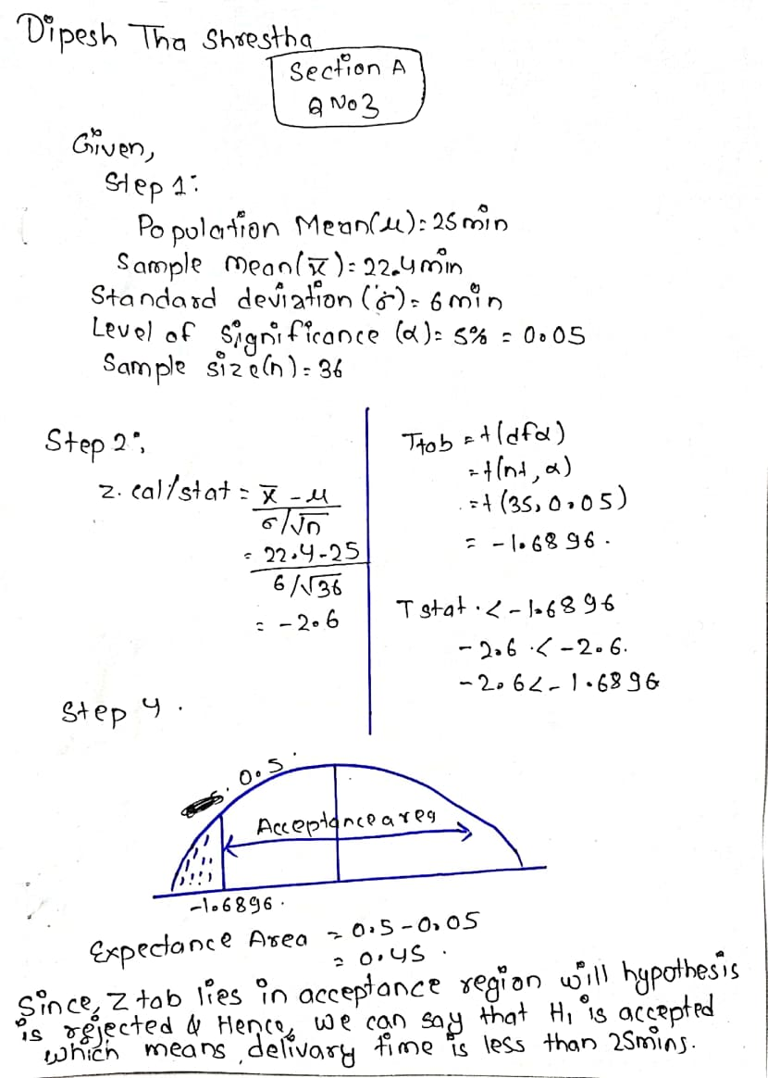

**Question 4**

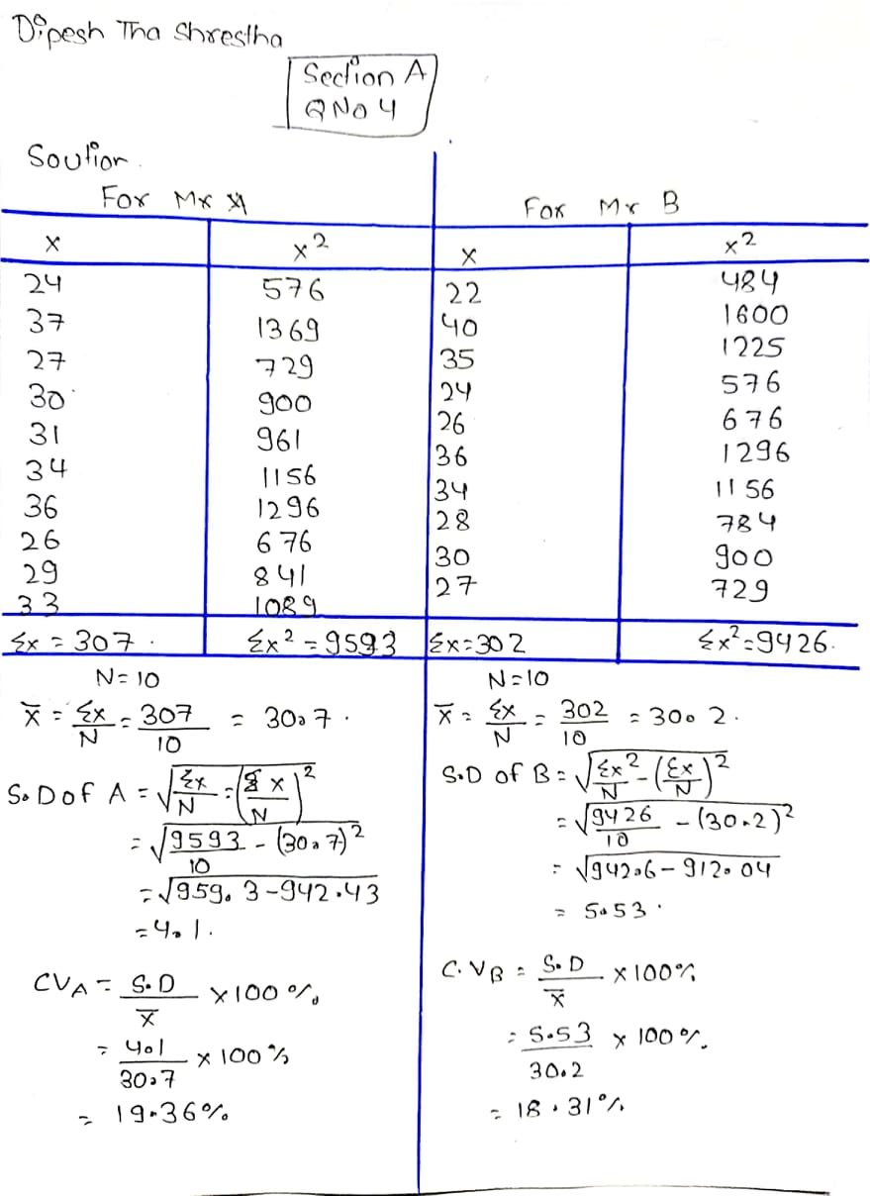

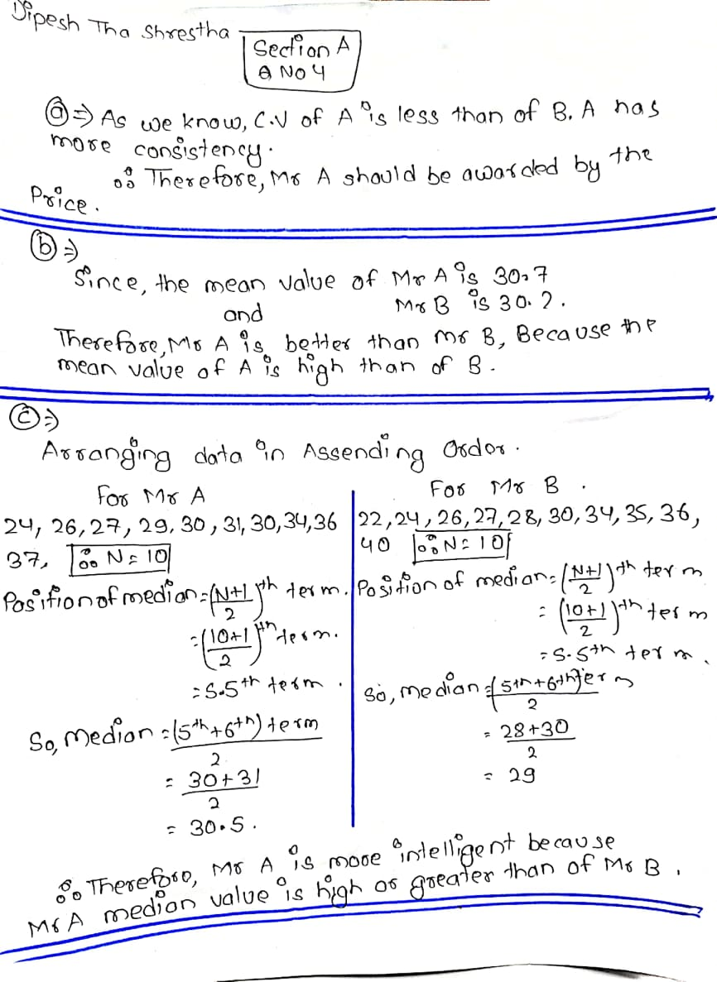 **Question 5**

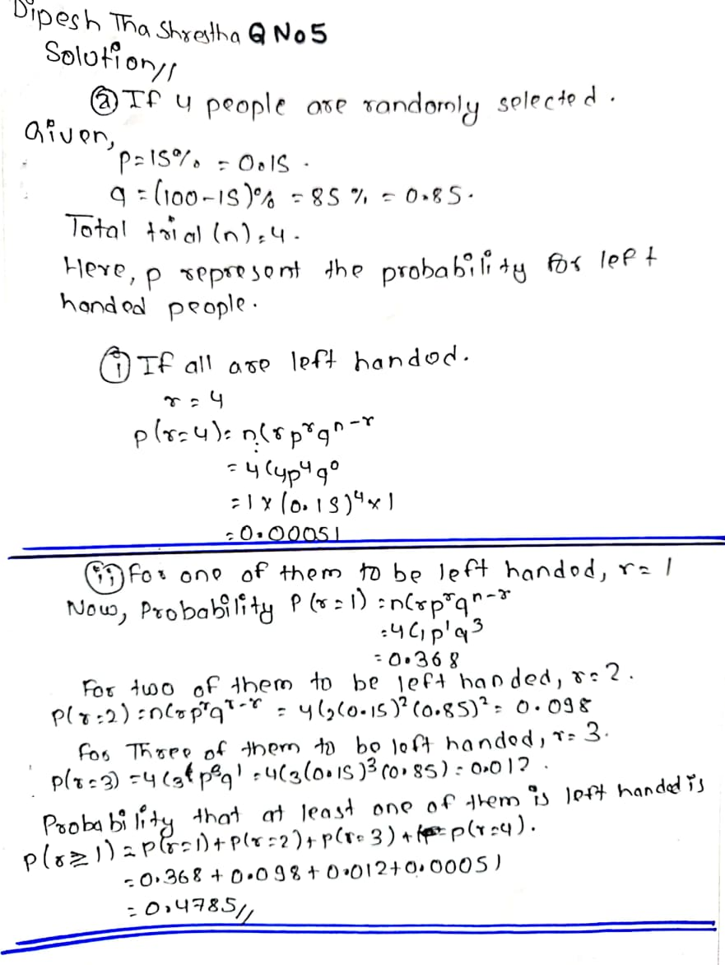

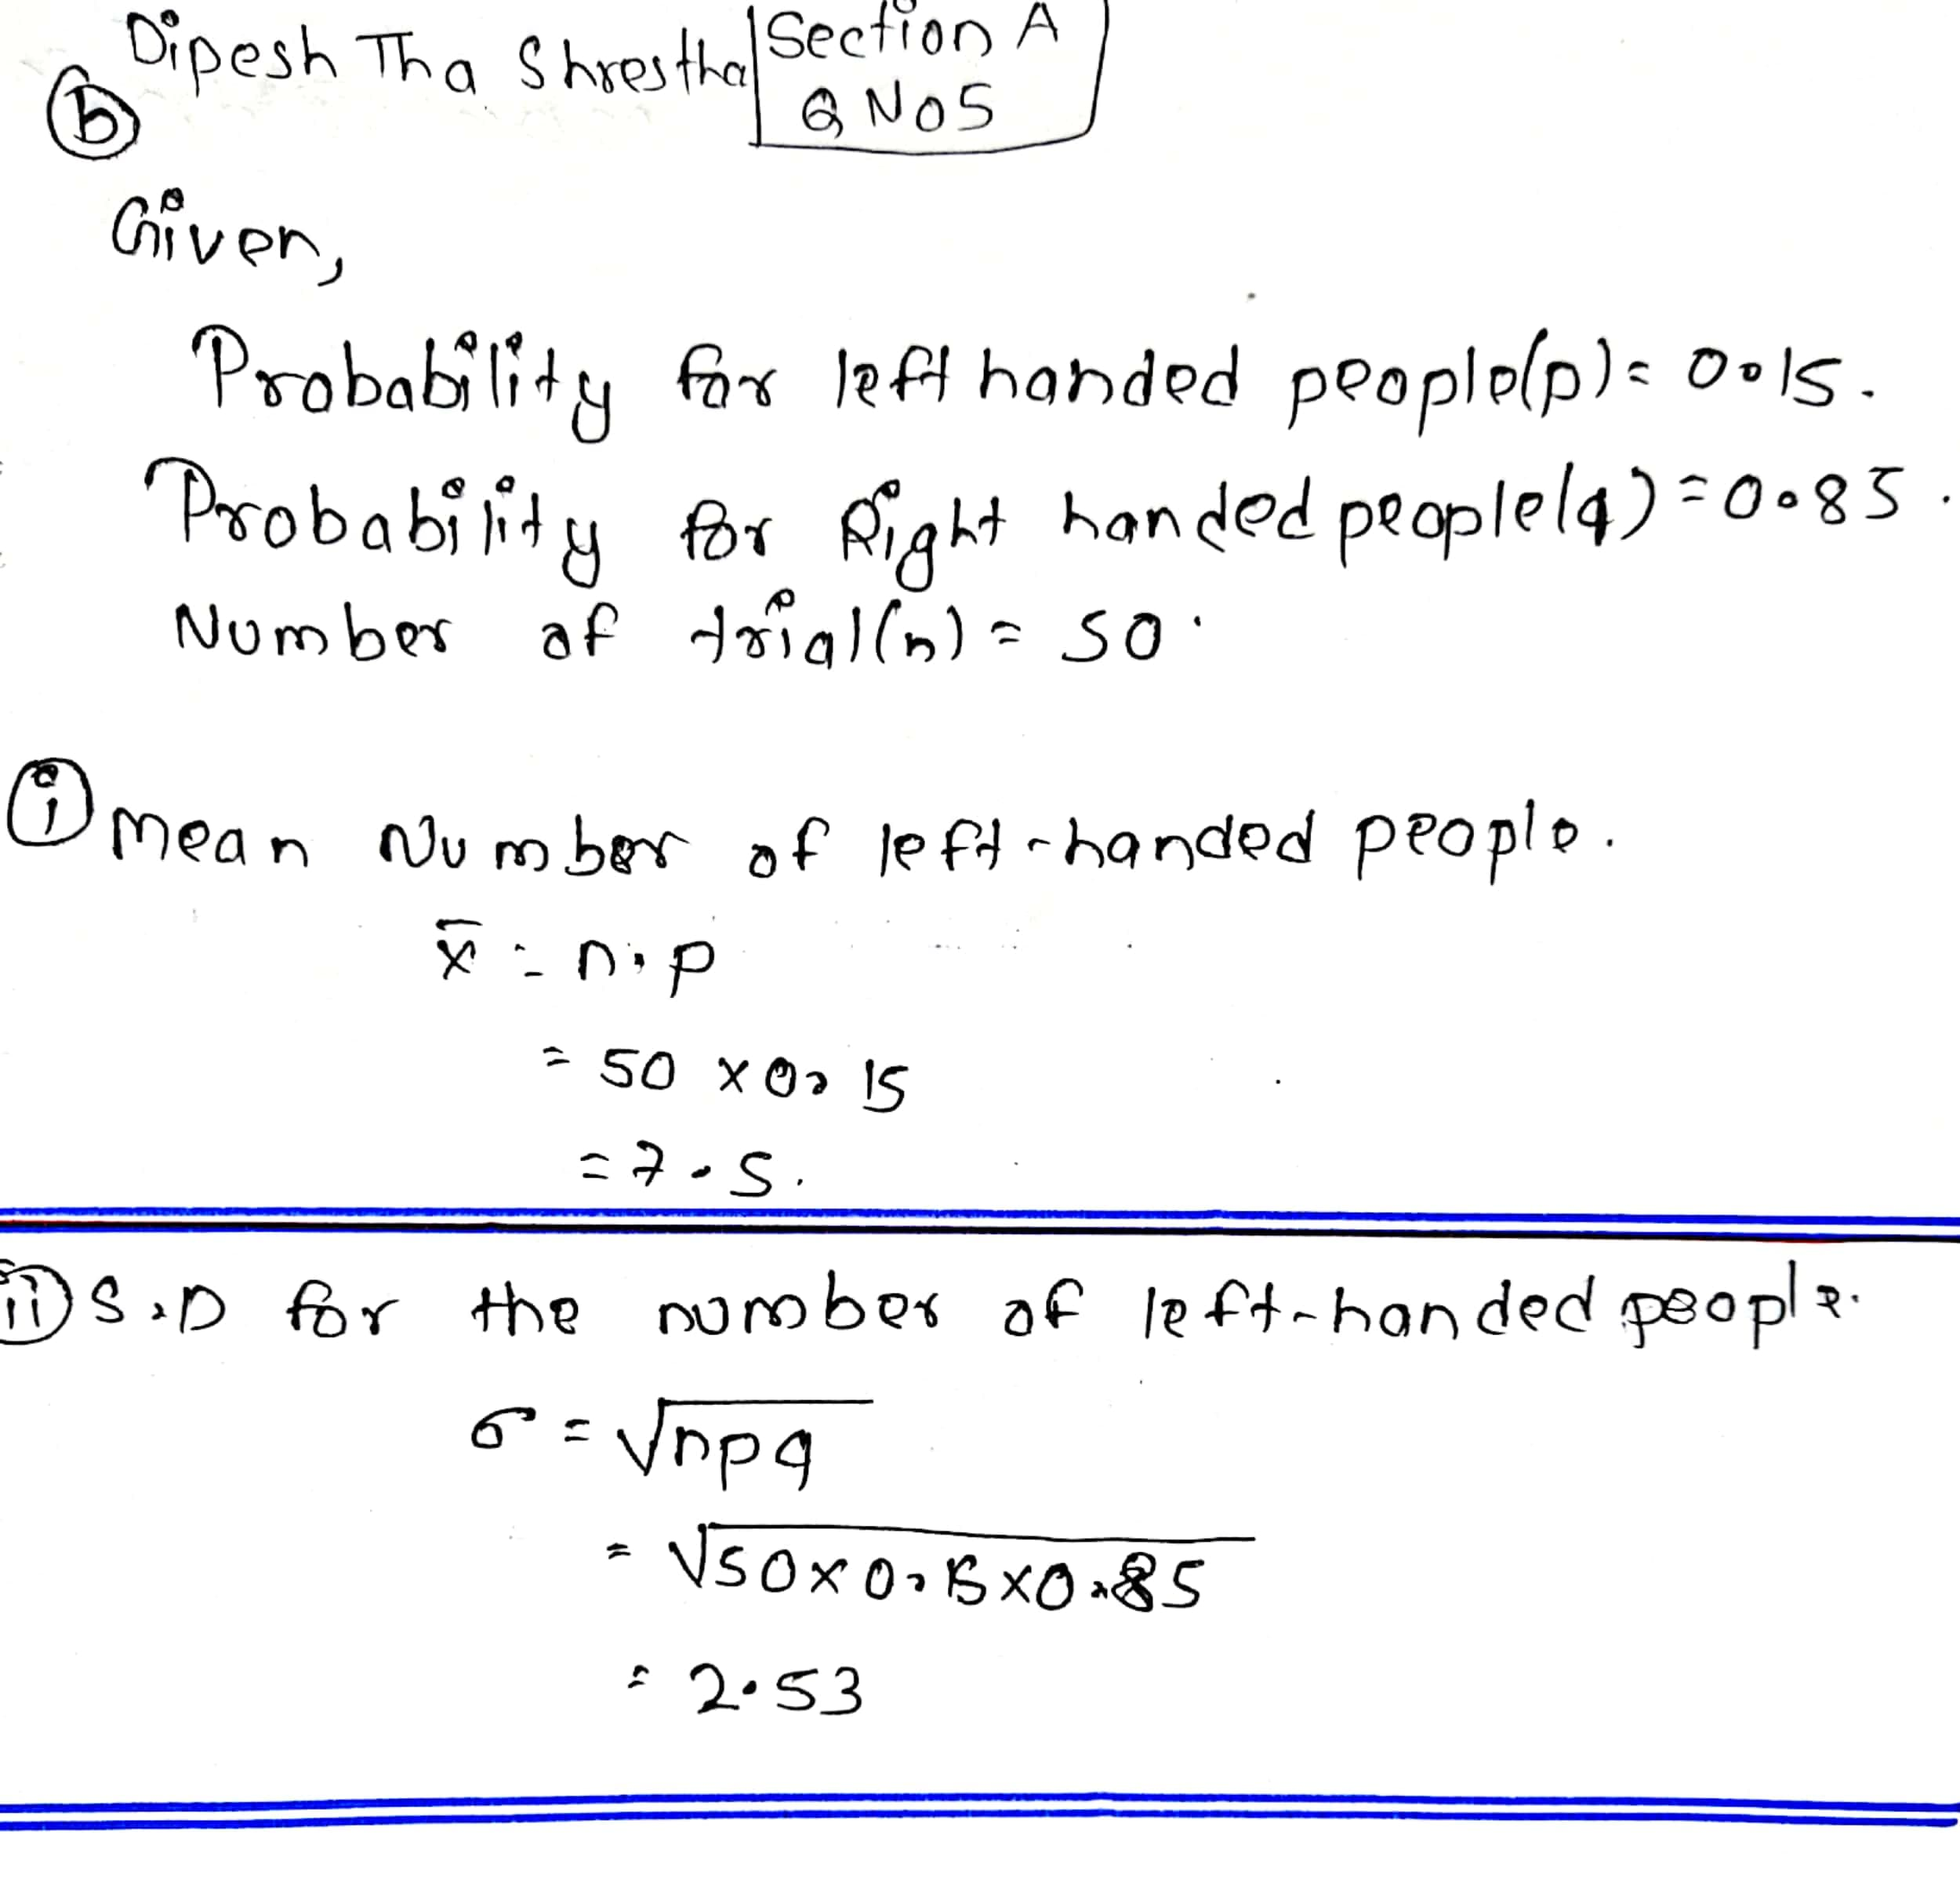

**Section B**

**Question 1**

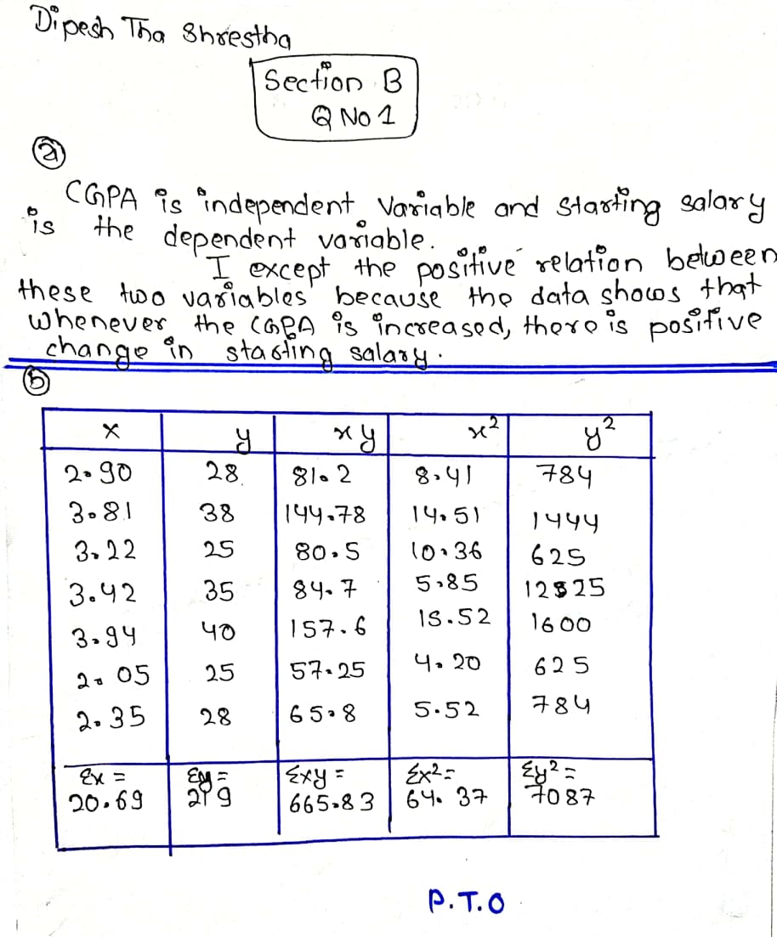

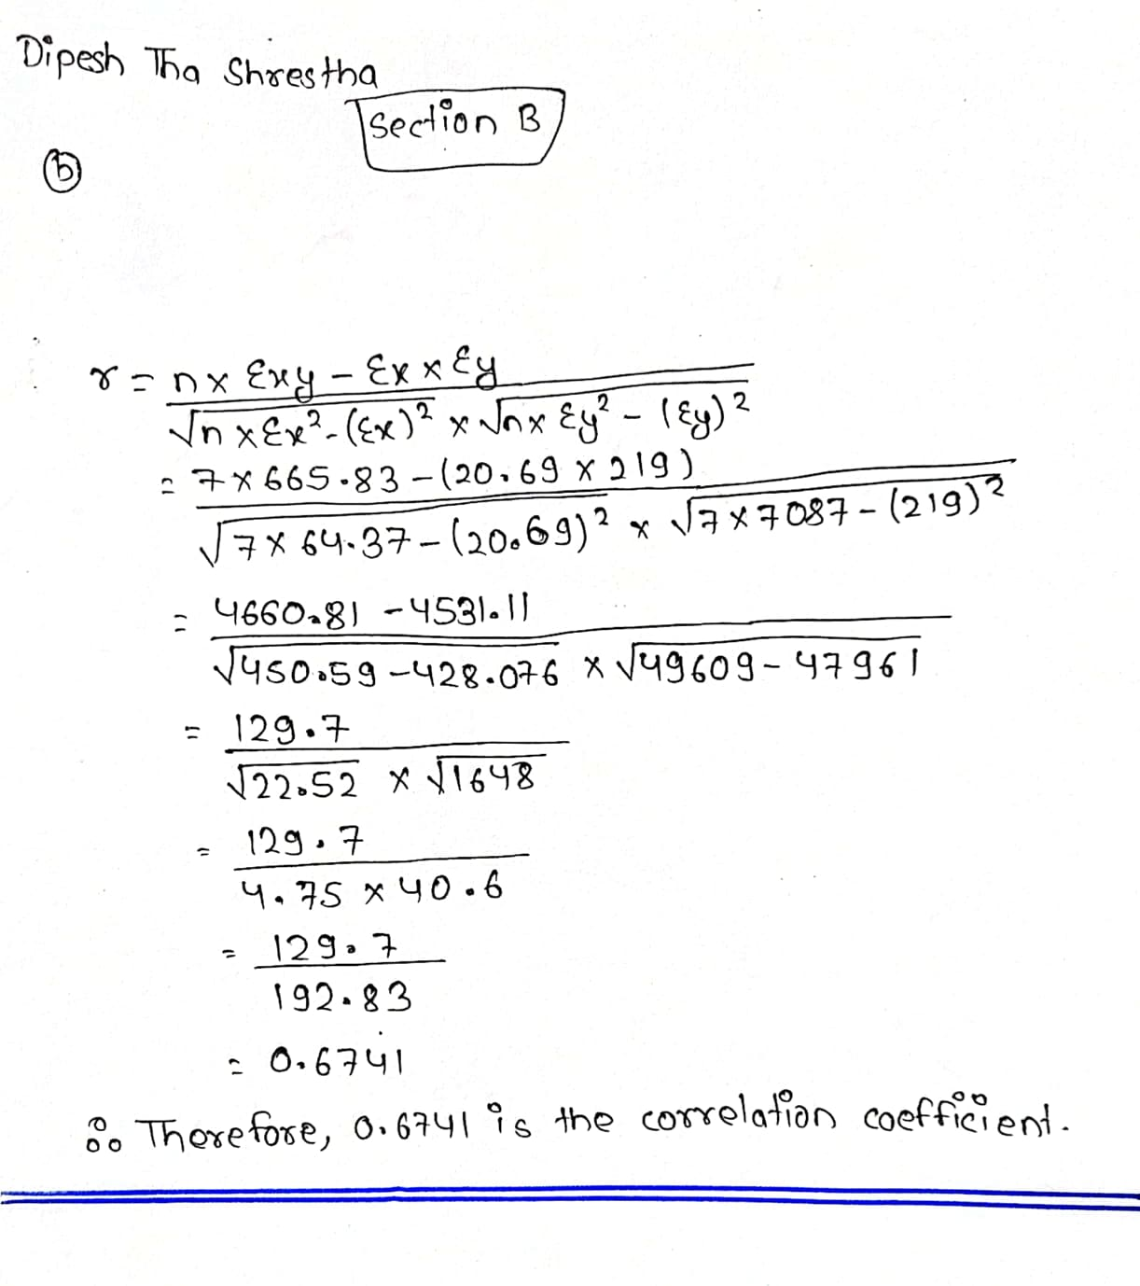

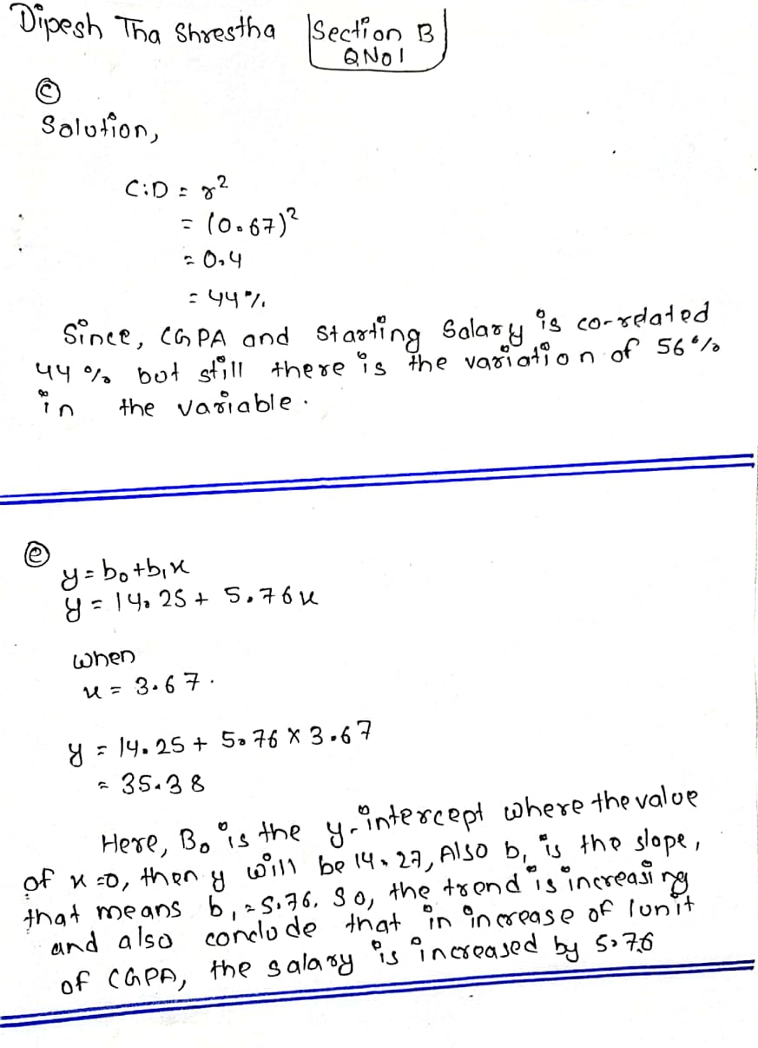

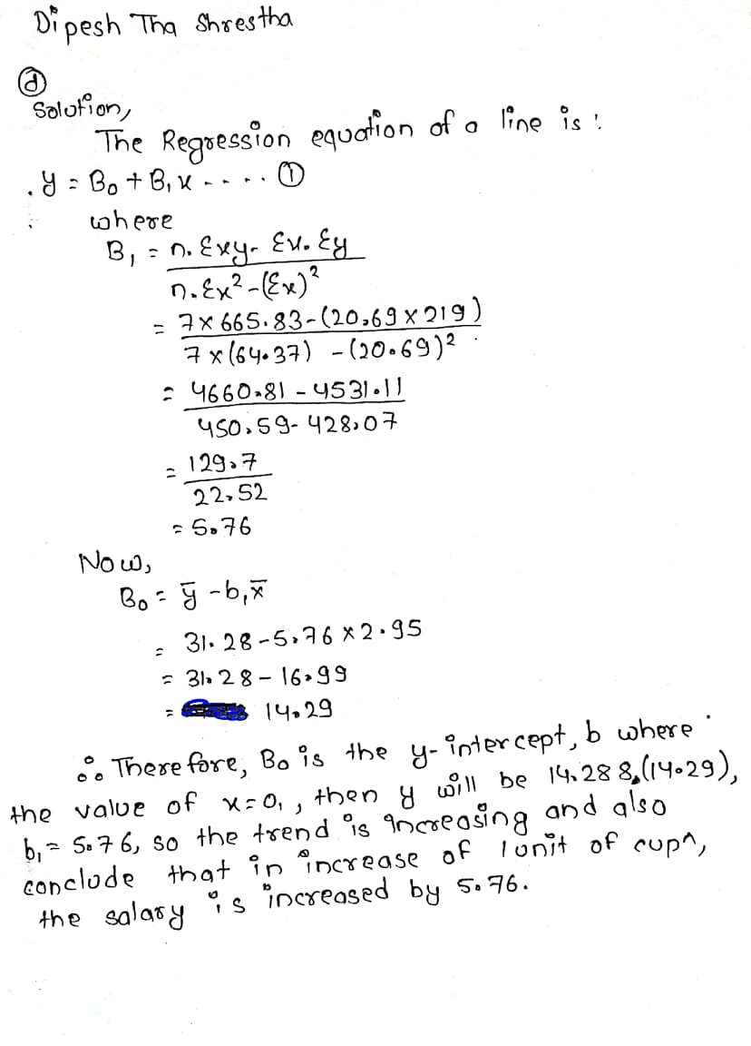

**Thank You**